CS341 Wireshark Homework #1
20150109 Donggyun Kim

(1) 1 GET message was sent.
(2) There were 2 TCP segments for the response.
(3) 200 OK
(4) One packet has a status line associated with “Continuation”.

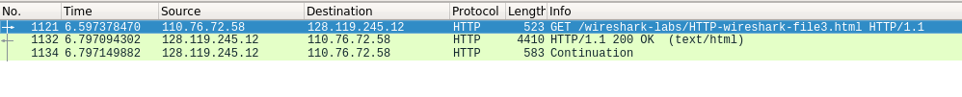
(5) 3 GET messages were sent, all to ‘128.119.245.12’.
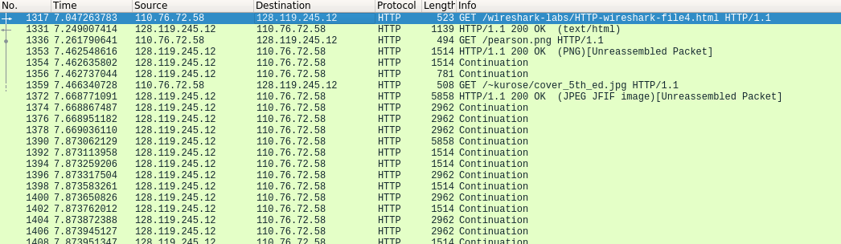
(6) Download was done in serial – the last GET message (for the second image) was sent (so the transmission of the second image started) after completion of the transmission of the first image.

